SEQUENCES
KS1 – 2001 Paper
1.
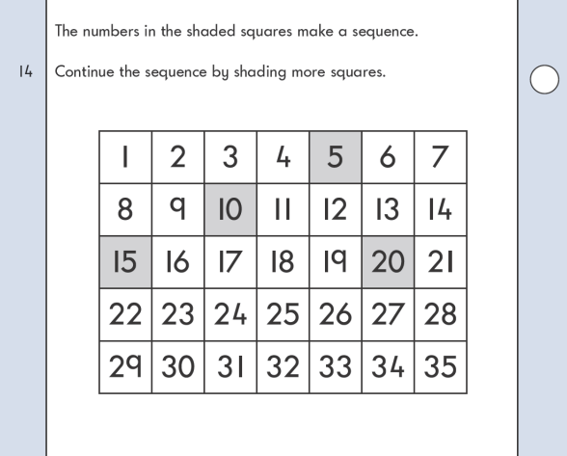
KS1 – 2002 Paper
2.
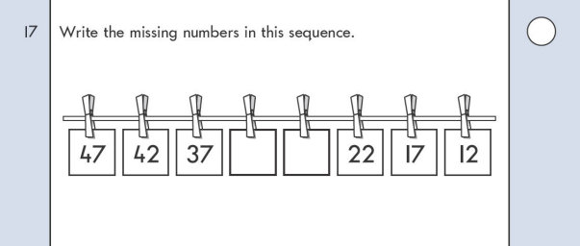
KS1 – 2003 Paper 1
3.

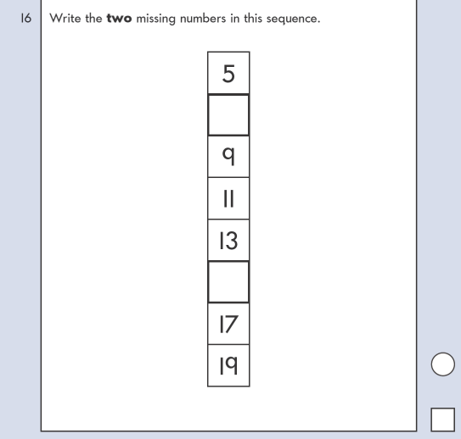
KS1 – 2004 Paper 2
4.

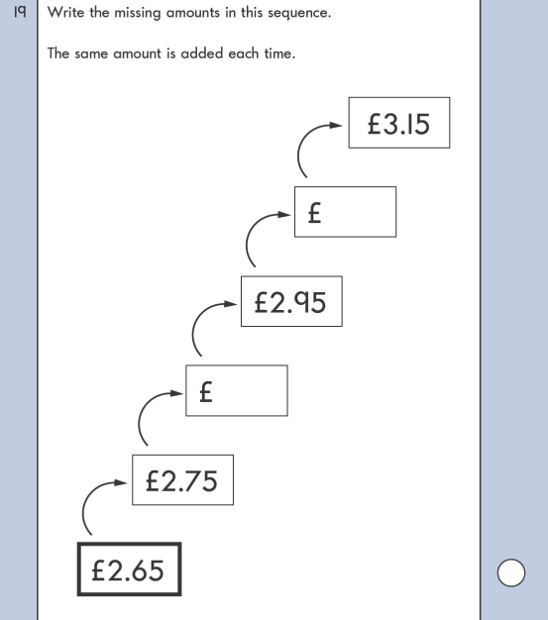
KS1 – 2007 Paper 2
5.

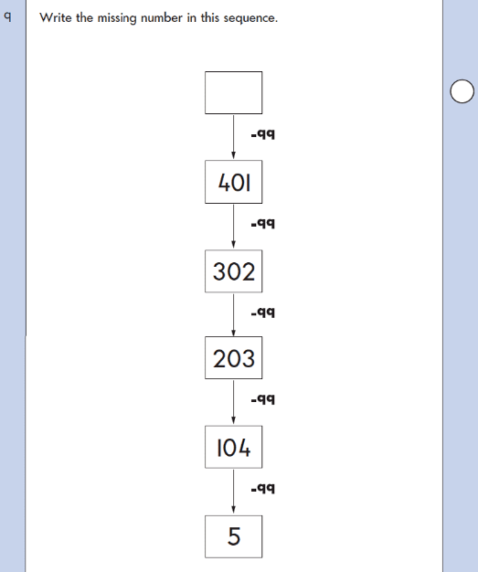
KS1 – 2009 Paper 2
6.

